ITHACA-Solve-RD partnership: ultrarare disorders
Opportunity of HCPs in ITHACA that are not members of Solve-RD to submit ONE carefully selected patient with ultrarare, unsolved phenotype for trio genome analysis.
Deadline: September 30, 2020

Inclusion criteria
- Patient with a very specific, “potentially recognizable phenotype” that does not fit a known entity, with no identified cause.
- Trio (parents/child available)
- CGH/SNP array normal
- Ideally: normal exome (not mandatory if phenotype really “extraordinary” and exome difficult to obtain locally.)

Prerequisite
- Fresh samples from the trio
- National consent for genetic screening for child and parents OR Nijmegen default consent
- ITHACA consent for data sharing in ERN (i.e. CPMS consent)
- Pdf file with clinical summary/history and anonymized pictures, submitted to Jill and Alain (by email or file transfer) → approval/suggestions within 15 days
- Pdf file uploaded to CPMS : please note “SolveRD Ultrarare study” in the nickname of the case (for archiving and activity reporting within ITHACA

Sampling

EDTA-blood
10ml EDTA-blood tube* is required. EDTA-blood can be shipped at ambient temperature but should arrive in Nijmegen within 48-72h after blood withdrawal.

DNA (only if a patient cannot be sampled: please favour fresh blood)
Ideally 10µg of DNA must be sent (absolute minimum to be shared with service providers per test is 3µg); but additional QC is performed at RUMC.
DNA can be shipped at ambient temperature, cooled (4°C) or frozen (-20°C or -80°C).

Shipping

Inform Lab
Before sending samples: inform the lab by email: genoomresearchweefselkweek@radboudumc.nl and/or contact Mw S. van der Velde-Visser (phone: 0031-24-3616731)

Shipping address
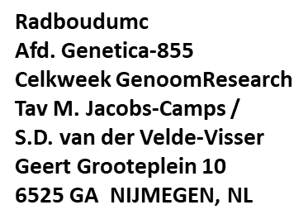
Samples can only be received Monday-Thursday between 8:00-17:00h, and Friday between 8:00-14:00h.
Send all material at room temperature.
Join a copy of the consent to the sample, and the identification form of the sender (next page)

Details of sender
Sender details will only be used for sample tracking purposes, and in case of calamities related to sample shipment.

SENDER | SOLVE_RD – Ultrarare project ITHACA
Name:
Initial(s):
Name of PI:
Institute:
Dept:
Street:
Postal Code:
City:
Country:
Email:
Phone:

