CPMS panel creation protocol
Table of Contents
1. Patient upload 2
1.1. Aim 2
1.2. Overview of the required steps 2
2. First login 2
3. CPMS home screen 4
4. Creating a panel 5
4.1. The Centre tab 5
4.1.1 Enrolling a patient 5
4.2. Opening a panel 6
4.3. Editing your panel 7
4.3.1 Uploading medical documents or a patient graphical abstract 8
4.4. Panel selection 11
4.5. Requesting additional data 11
4.6. Data completion 13
4.7. Scheduling a meeting 13
4.8. Assessment 14
4.9. Outcome 14
4.10. Sign-off and close the panel 16

* Original Draft v.07.08.2020, produce by ERN eUROGEN and adapted to ITHACA v 20.08.2020

- Patient upload
  - Aim
This document describes the steps required to both enrol a patient and create a panel in CPMS.
  - Overview of the required steps
- Active CPMS access
- Check patient informed consent
- Enrol patient in CPMS
- Create a panel for the enrolled patient
- Add the required medical information
  - Using the online CPMS forms
  - Or creating a graphical patient abstract
- Select and invite the panel members
- Wait for acceptation and provide additional information if requested
- Schedule the panel meeting
- Provide the panel outcome after the meeting
- Move the panel to the closed phase

- First login
Before trying to access CPMS, you will need to create an EU login and make a CPMS access request. This process is described in a separate document (For more info see: Ithaca web page ).
Once this is completed and authorised you will receive a confirmation email that your access was approved after which you can login for the first time in CPMS. https://cpms.ern-net.eu
- When logging in for the first time your professional role and personal preferences are requested, namely your role and thematic area.

- Type in your professional role (this will be shown beside your name in panels)
- Choose a thematic area of the ITHACA where you requested access for
- To save these preferences please click Update preferences
- To update your preferences at any time, simply click on the ERN tab at the top screen

Thematic Area
- Craniofacial malformation syndromes
- Disorders of growth impairment
- Hearing loss syndromes
- Non-syndromic intellectual disability
- Other multiple anomaly syndromes
- Overgrowth disorders
- Syndromes involving skin/integument
- Syndromic CNS disorders
- Syndromic cardiac disorders
- Syndromic eye disorders
- Syndromic intellectual disability
- Syndromic skeletal dysplasias
- Syndromic genito-urinary disorders
- Syndromic haematological/immunological disorders
- Syndromic obesity/endocrine disorders
- Teratogenic disorders

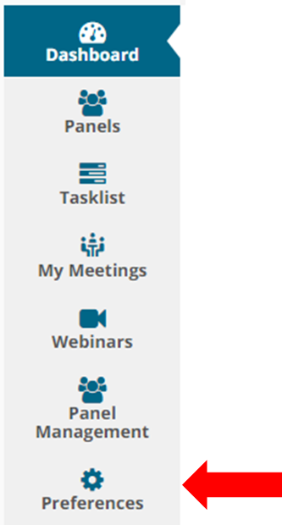
At any time you can change your preferences
Then click on Preferences in the left bar, this will open the Preference tab again.

- CPMS home screen
After logging in to CPMS, the home screen is shown.
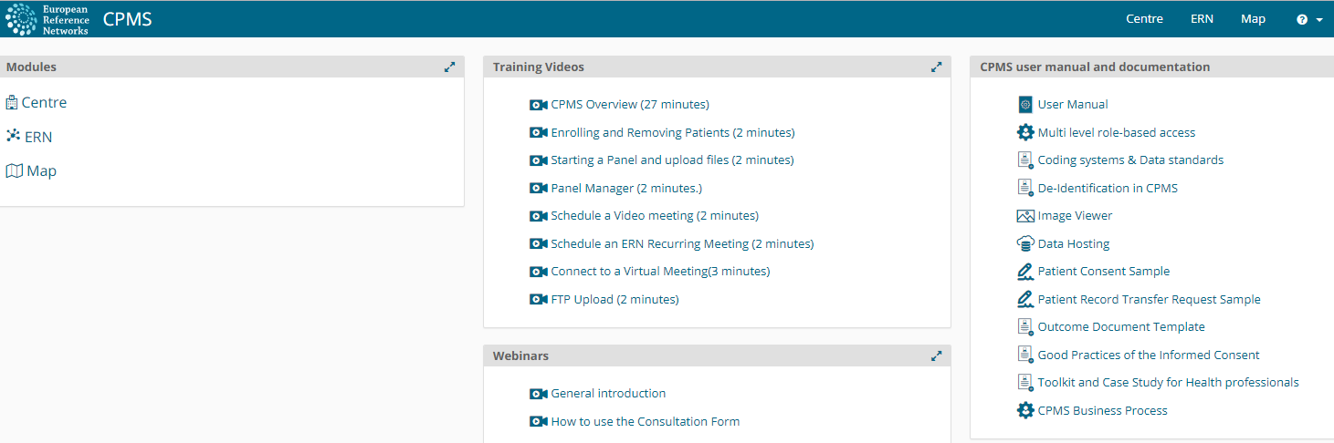
- Modules
  - contains the Centre, ERN and Map tab
- Training videos
  - Useful video for when using CPMS for the first time, some important videos are the CPMS overview, Enrolling and removing patients and Starting a panel and upload files
- Webinars
  - Here are several explanatory videos where recent new functions are also explained
- CPMS user manual and documentation
  - Contains documents concerning several CPMS functionalities

- Creating a panel
  - The Centre tab
This tab contains the patients included in your centre (healthcare provider) only. From this tab your local patients can be enlisted and managed. The most important difference with the ERN tab is that patient data is not anonymous in this section.
    - Enrolling a patient
- When in the Centre tab, click on Enrol patient
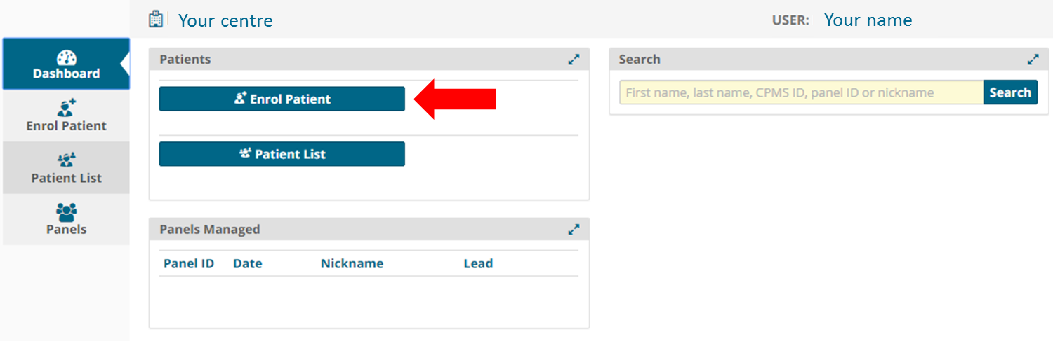
- This will open a tab where you can fill in the patient’s data
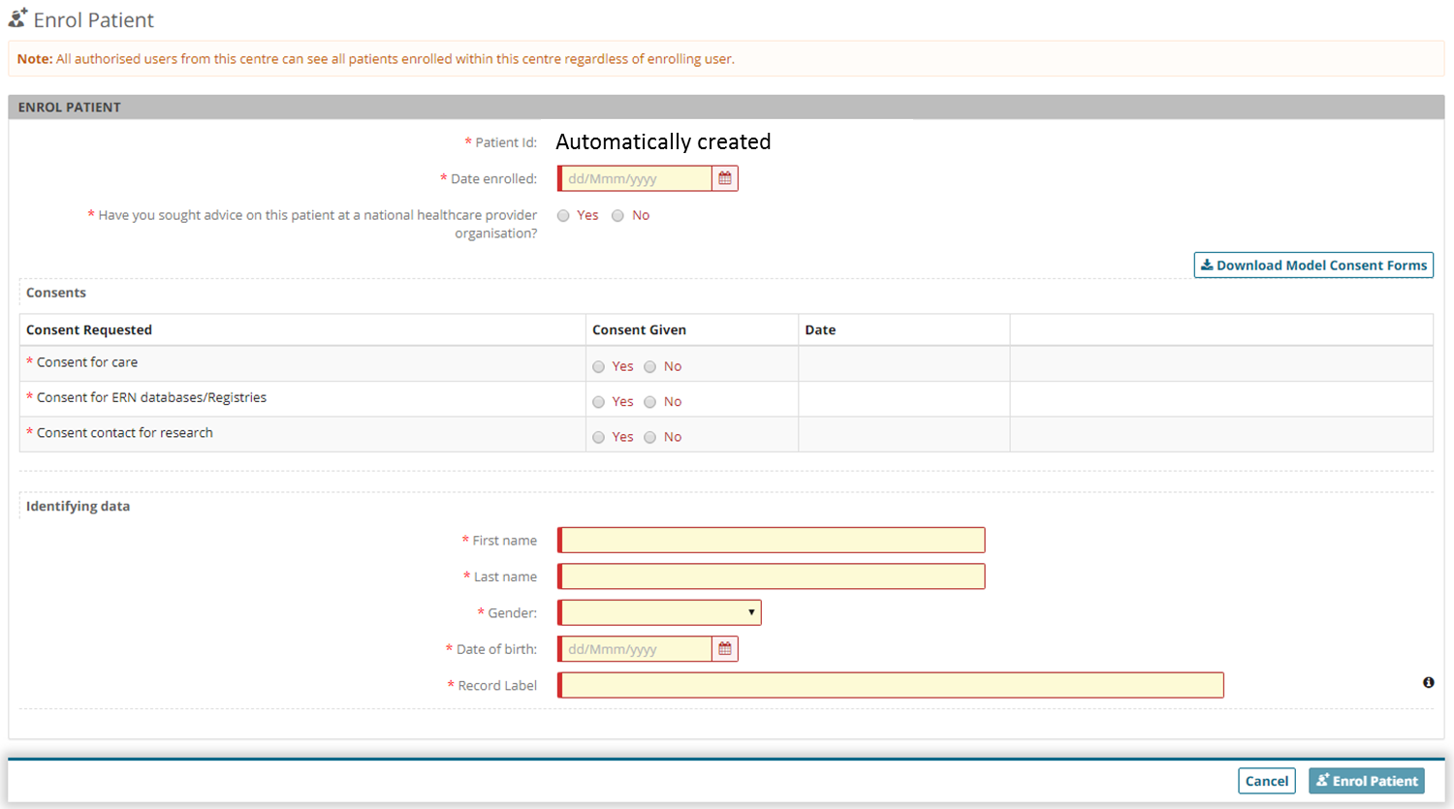
- At patient ID a name is automatically created
- The consent forms can be downloaded by clicking on Download model consent forms
- The consent forms are not uploaded in CPMS but locally stored
  - please make sure they are saved with the patients’ file and can be found again (eg if patient removes consent)
- Fill out the required fields to complete the enrolment
  - No specific medical information is required here
  - The record label is automatically created but can be adjusted if desired
- Once finished click on Enrol patient
- The next screen will give you the option to open a new panel
  - Opening a panel
- After enrolling a patient, you will automatically continue to the option to open a new panel
  - You can also access this option for previously enrolled patients by clicking on Centre > Patient list > select the patient you want to open a panel for
- Click on Open a new panel
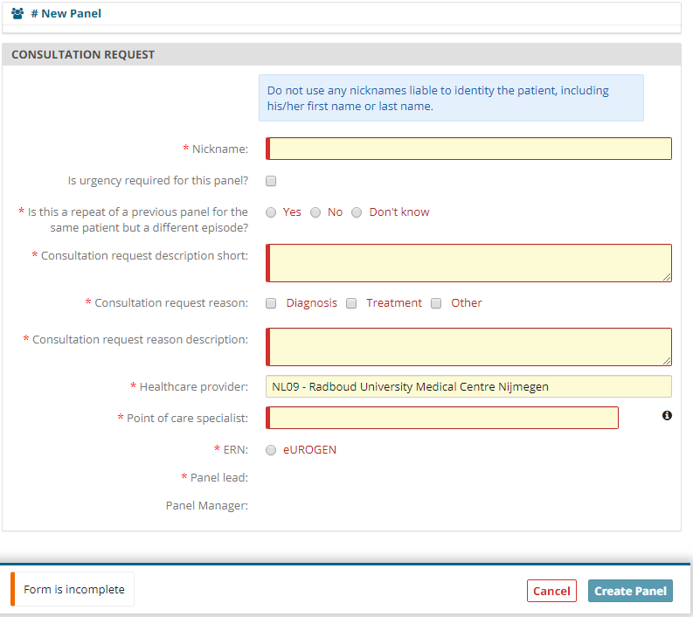
- From here on the patient data will be processed anonymously therefore, a nickname is required
  - Centres using an electronic patient file often use local patient numbers which are different from social security numbers. An option is to use the local patient number as a nickname because it can only be connected to the patient at the local centre by authorised personnel
  - As an example, at the Radboud centre we use NL09RBNR[local patient number] as a nickname. the NL09 is the code for our centre followed by RBNR which is short for Radboud patient number, followed by the patients’ number
- Fill out the required fields to complete the form
  - At the point of care specialist, the name of the main treating physician of the patient is mentioned
  - note that initially, the Panel Lead can only be set to be someone in your Centre, but this can be changed later on. Guest users will not have the option to choose a Panel Lead.
  - Select the panel lead from a list of locally registered CPMS users
  - If available, select a local panel manager
- When you have anonymous files to attach please do NOT use the attachments button shown below. Files added here are only visible for local ITHACA members and NOT for panel members. The process for adding files to your panel is described below.
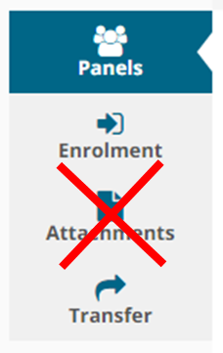
- Once all fields are completed click on Create panel to complete this form

  - Editing your panel
- You will now see the panel overview screen like the example below
- In the consultation request you will find the data you just entered
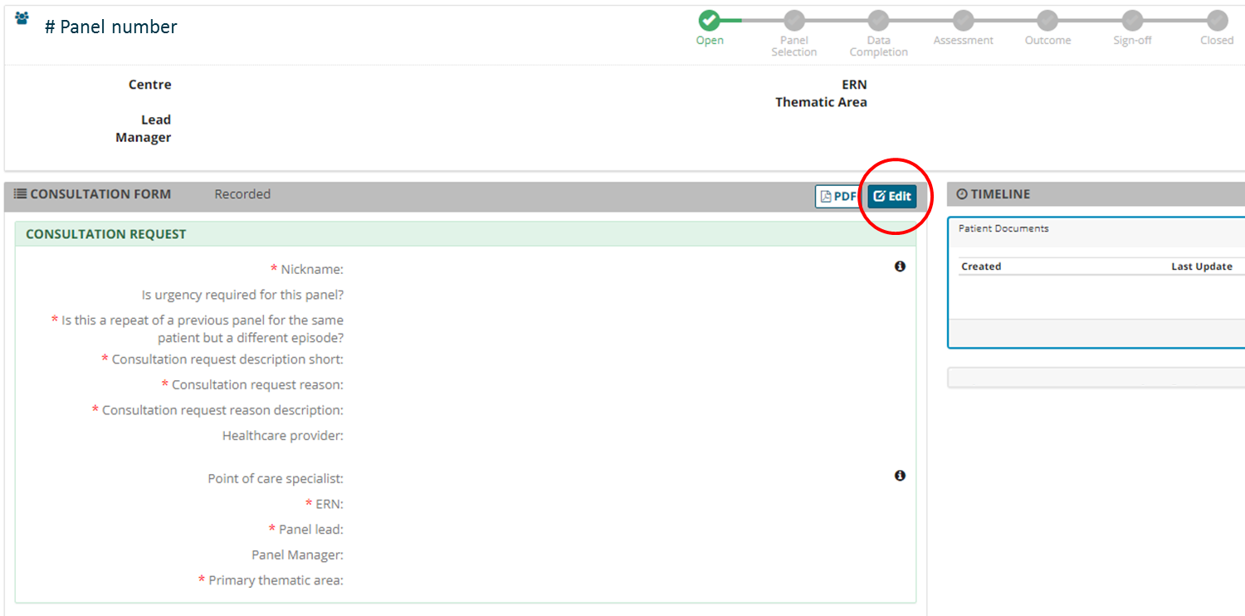
- To provide medical information regarding your case click on Edit
  - Please note: You should include as much information as you can at this stage, as you will be unable to add more at the next stage, whilst you are inviting people to the panel.
- On the left you will find a column with specific medical subject, check the box next to it top open this heading and provide the information
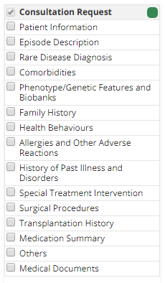
- You can provide the patient information that you find essential to each specific section and click on Save to finish editing the patient data
- The newly added information will be shown after saving in the panel overview, here you can check for correctness and completeness
    - Uploading medical documents or a patient graphical abstract
- Alternatively, rather than adding patient information to each of the predefined sections, a graphical patient abstract can also be made and uploaded to CPMS as a PDF file
  - When doing this we recommend creating a patient abstract in PowerPoint with inclusion of essential media files and then saving this as a PDF file
  - When using screenshots in your abstract, please remove all patient identifying data
- To upload a graphical patient abstract or medical documents check the “Medical documents” section
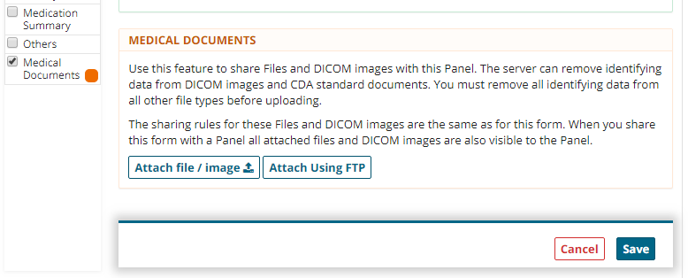
- Click the Attach file / image button to upload files
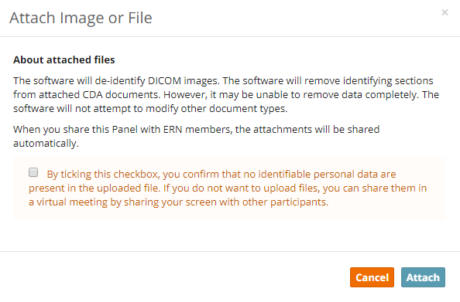
- Confirm that no patient identifiable information is included in the file you want to upload
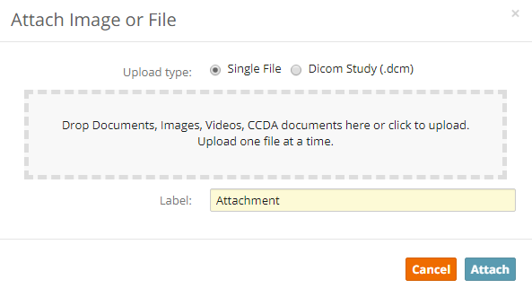
- You can then select of drag files from your computer folder to attach them
- Provide the file with a label and click Attach
- After the loading bar is complete the file can be seen under the heading Files / images
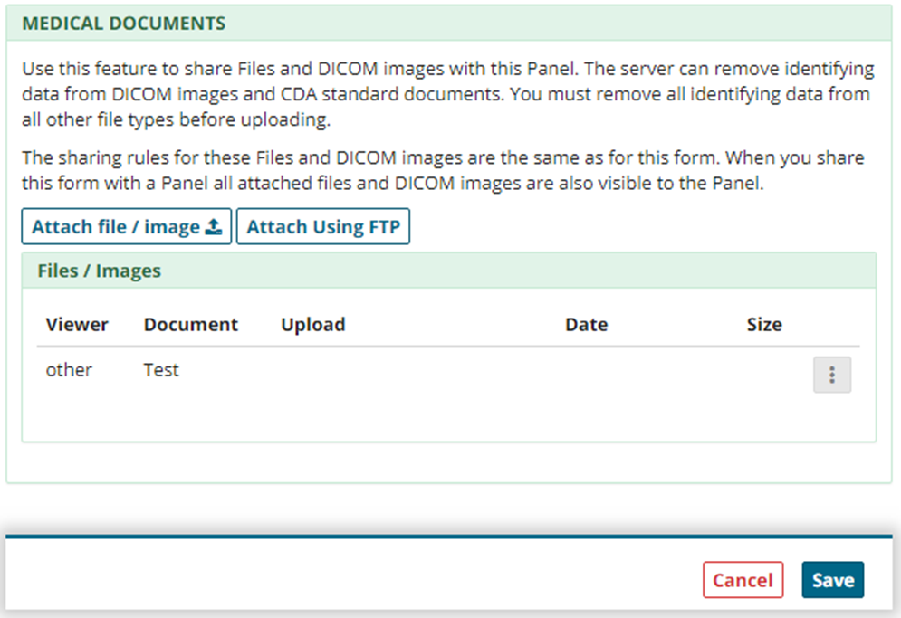
- Click Save to finish the uploading of files
- In most cases, where only a few documents are being uploaded and they are less than 100 MB, the method described above is recommended. However, should you have a very large file or dozens of files to upload, you may want to try using the FTP upload. For the use of the FTP upload functionality, we recommend the training video regarding this subject which can be found in the CPMS home screen
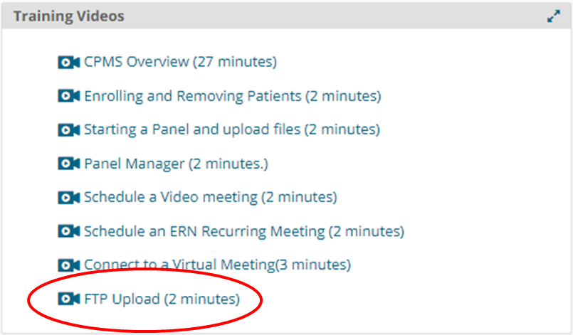

  - Panel selection
- After finishing the patient information and possible uploading of medical documents, you can move one to the panel selection
- When viewing the panel overview after editing of the data, you can click the Next button in the right upper corner of the screen
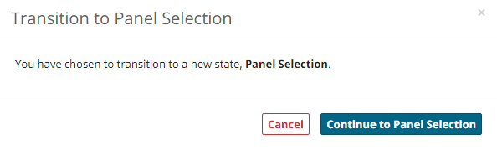
- A popup will appear asking you to confirm the transition to the panel selection phase
  - Note: after transiting to the next phase you will NOT be able to add new patient information until after the panel selection phase. This will be corrected after the update in Q3 2020
- Click Continue to panel selection
- You can then start with inviting panel members by clicking on Invite members
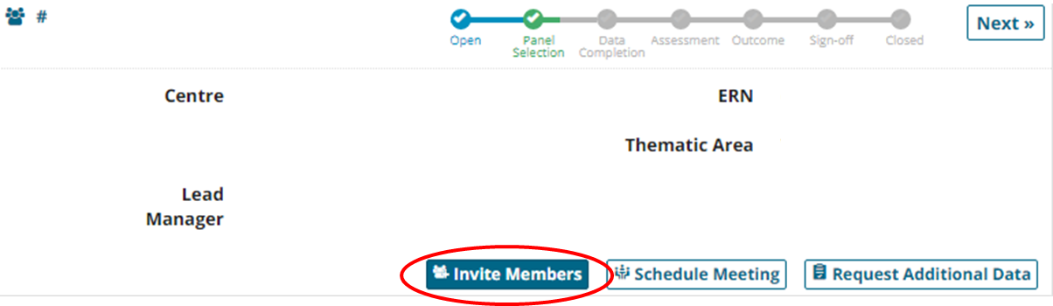
- This will bring you to the panel selection screen where you can click the Available tab
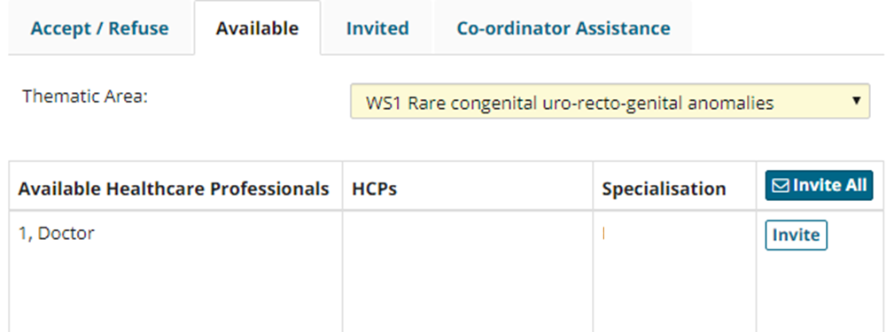
- Here you will be provided with a list of connected healthcare professionals for each workstream
  - Make sure the right Workstream is selected
  - Click on the Invite button to send an invitation to the healthcare professional
  - Requesting additional data
- Once participants have accepted your invitation, they can also request additional information
- When this is done you will receive an automated email that additional data has been requested
- If you login to CPMS and go to ERN > Dashboard > Requests for additional data
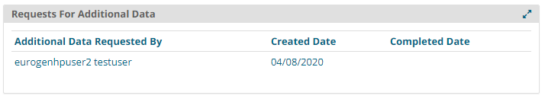
- This shows the data request, click on it to go the panel overview
- In the timeline column on the right side, the request is shown
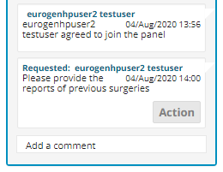
- Click on the Action button to add the additional data
- In this screen you can respond to the panel member
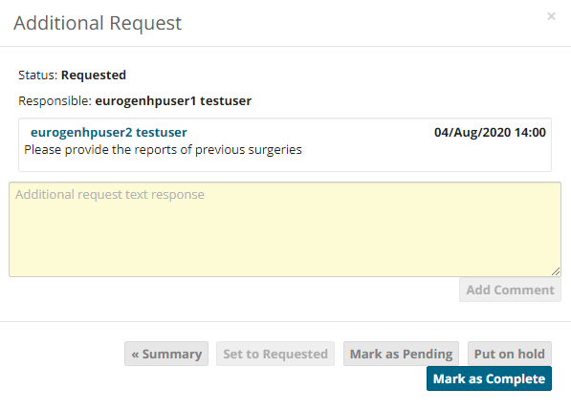
- If additional data is still needed, click on Mark as pending to let the panel know you have read the request
- Once you have provided the additional data click on Mark as Complete to sign off the data request
- Your response will appear in the timeline column on the left

  - Data completion
- Once you find enough panel members that have accepted the invitation you can continue to the data completion phase. In this phase:
  - you will not be able to invite additional panel members
  - You can edit the patient data again similar to the start of the panel
- In the panel overview, click on Next
- A screen will show you all the panel members that have accepted the invitation
- Click on Continue to Data Completion
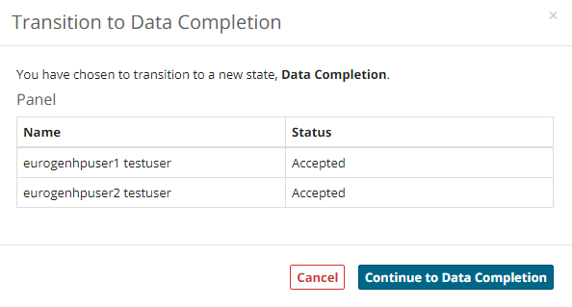
  - Scheduling a meeting
- Once enough panel members have joined and there is no request for additional data a meeting can be scheduled
- In the panel overview click on Schedule meeting
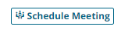
- This will open the following screen
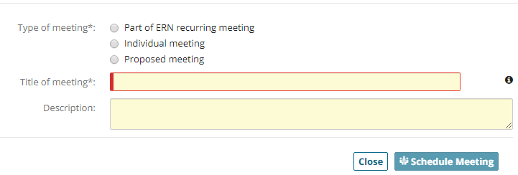
- Type of meeting
  - Part of ERN meeting: will show regular ERN meetings where a panel can be discussed beforehand
  - Individual meeting: a single meeting at a specific time and date
  - Proposed meeting: multiple time slots can be added, and panel members can mark their preferences
- Click on Schedule meeting to continue
  - Assessment
- When the panel has been discussed and an outcome has been provided the panel can move to the assessment phase
- Click on the Next button to proceed from the data completion phase and confirm this
- The panel will now ask you to record the contribution
- Click on Record Contribution
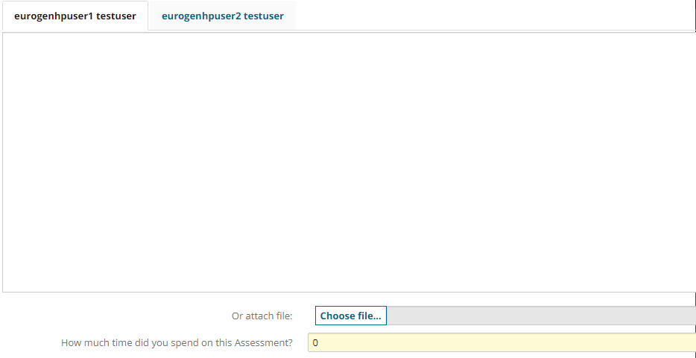
- Here you can fill in the contribution of each panel member and provide the amount of time spent on the panel assessment
- Click on Record My Contribution to save this

  - Outcome
- Once the contribution has been recorded, the outcome phase can be entered
- Click on the Next button to continue and confirm this
- Click on Record outcome
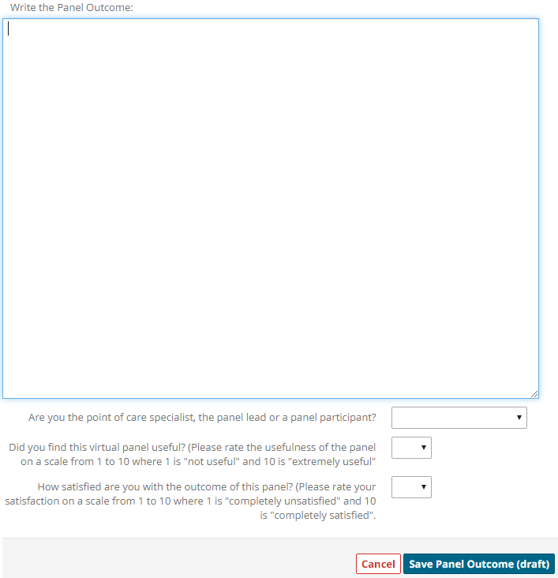
- Fill out the panel outcome and select your role in this panel
- Provide the usefulness and satisfaction score by selecting a number from the drop-down menu
- Click on Save Panel Outcome when finished
- You will see the recorded panel outcome appear in the timeline on the left
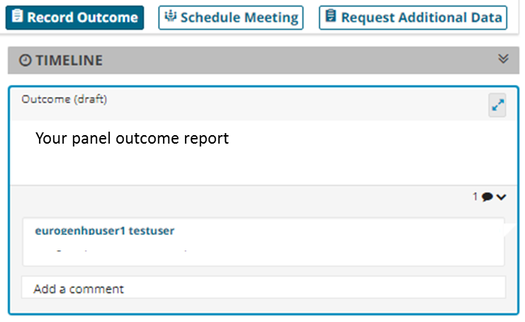

  - Sign-off and close the panel
- After writing the outcome report the panel should be moved to the sign-off phase
- Click the Next button to continue and confirm
- Above the timeline the Sign-off outcome button will appear
- Click the Sign-off Outcome button
- The outcome report can be adjusted if needed
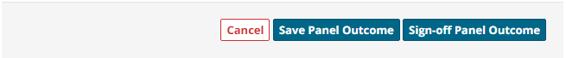
- When finished, click the Sign-off Panel Outcome button and confirm
- An outcome document can be created
- Click on Outcome document
- This will open a new window with a PDF document of the panel case and outcome document
  - We recommend this document to be locally saved and attached to the patient file
  - We recommend that this document is shared with the patient by the treating clinician and discussed when planning future treatment
- To close the panel, click on the Next button
- This will open the final screen
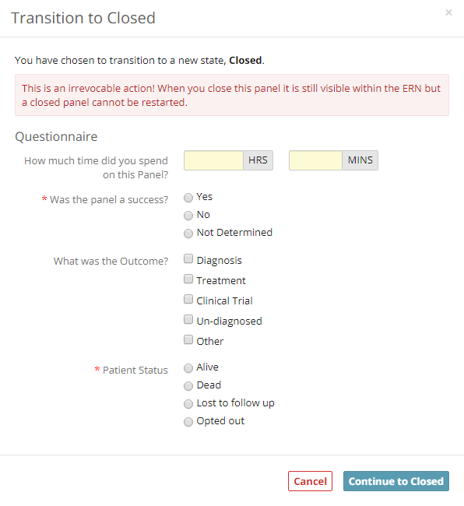
- Please provide the requested information
- Click Continue to Closed
  - Note: this action is irrevocable
- Your panel phase will switch to Closed, and it is now finished
  - The Archive option removes the panel from the ERN list and makes it only visible for the local centre. We recommend not to use this option unless advised by ITHACA team members or upon request of the patient.

Within the framework of inter-ERN collaboration, ERN eUROGEN has allowed ERN ITHACA to produce an adapted version of the guidance document for their network

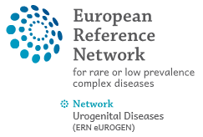 | 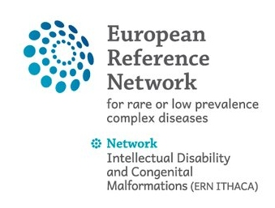
http://eurogen-ern.eu/ | https://ern-ithaca.eu
ERN eUROGEN and ERN ITHACA are two of the 24 European Reference Networks (ERNs) approved by the ERN Board of Member States. The ERNs are co-funded by the European Commission. For more information about the ERNs and the EU health strategy please see here: https://webgate.ec.europa.eu/ern/

