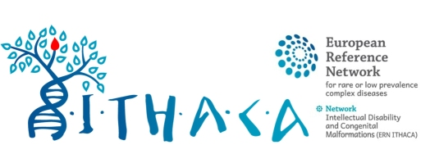

Call for collaborative clinical research on developmental disorders

These calls for collaborative projects typically aim to rapidly build up consistent clinical series for rare monogenic disorders, in order to better delineate the clinical spectrum and natural history of recently identified entities in the field of ITHACA. The call will be disseminated to the mailing list of ITHACA and will be posted on the web site, with regular reminders.

ITHACA Team will follow up the success of the call during the year that follows its publication. Any publication issued from this call should acknowledge ITHACA.

- Short title of the study:

- Targeted gene(s)/phenotype/disorder under study (to be quoted in the newsletter): (OMIM # or ORPHA code )

- Summary (1000 letters max):

- Coordinating clinician:
- Institution (dept, hospital, City):
- Contact email:

- Specific requirements beyond clinical data and genotype data sharing:
- Re-analysis of DNA samples: Y/N
- Resampling of patients: Y/N
- Linked to a translational/basic research project? Y/N

